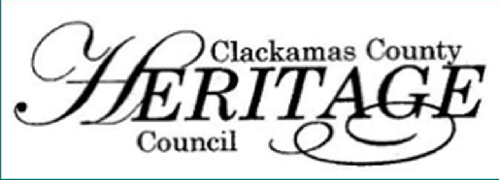THANK YOU FOR YOUR MEMBERSHIP IN 2023:

CLACKAMAS COUNTY HERITAGE COUNCIL
2024 MEMBERSHIP RENEWAL FORM

The work of the Council has continues with:

Annual Meeting (December) Social hour

Annual meeting presenting and approving updates to our By-Laws.

Monthly Zoom meetings with speakers on topics useful to members.

Member meetings held at several member organization sites including tours.

Created a travelling CCHC Display booth with canopy and graphics promoting Heritage.

Booth display events at several public and organization events. Great advertising for you all.

CCHC Newsletters listing member activities, news of importance, and meeting announcements

Upgraded website with additional features to attract visitors to heritage sites.

Local Television interview and advertising for promoting the “Heritage Pass”

YOUR MEMBERSHIP IN 2024 WILL ENHANCE ALL OF OUR GOALS:
.
- Using social media and the CCHC website for advertising and to create awareness of your events
and organization.
- Creating new, common themes for our organizations: Timber, Education and Transportation.
- Engaging diverse groups such as Oregon Black Pioneers and the Confederated Tribes of the
Grande Ronde, the new History Club, and the Oregon City Heritage Coordinating Committee
- Connecting withother local and regional tourism organizations and governments.
- Engaging with diverse groups such as Oregon Black Pioneers and The Confederated
Tribes of the Grand Ronde.
- Learning from each other and experts about successful projects to increase visitation and awareness.
- Expanding our membership and involvement in Clackamas County.

PLEASE RENEW YOUR MEMBERSHIP TODAY . . . TOGETHER WE CAN STRIVE
TO KEEP HISTORY ALIVE IN CLACKAMAS COUNTY

Use the form provided to renew your membership or visit www.clackamasheritage.org to pay online. If you have any questions
or would like a representative to speak to your board, please contact CCHC’s Membership Chair at
clackamasheritage@gmail.com. Thank you.
Elaine Butler; Philip Foster Farm Chris Guntermann, Baker Cabin Historic Society
President and acting Secretary Board Member at large
THE CLACKAMAS COUNTY HERITAGE COUNCIL’S MISSION IS TO COOPERATE TO
PRESERVE, ENRICH, AND SHARE CLACKAMAS COUNTY’S HERITAGE

2022 RENEW MEMBERSHIP FORM – Page Two

2022 MEMBERSHIP FORM – Renewing Members

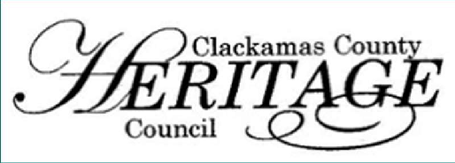MEMBERSHIP LEVELS

CLACKAMAS COUNTY HERITAGE COUNCIL
2024 MEMBERSHIP RENEWAL

Active Members: A non-profit or for-profit entity that displays heritage in Clackamas County or its environs. which preserve, display, portray, or bring to life memories, objects, buildings, sites, documents, books, photographs, artwork, and who conduct similar activities that provide meaning to the human experience.
Individual Members: All other individuals that support enriching, preserving, and sharing Clackamas County’s heritage community and resources.
Sponsoring Members: Vendors, corporations, and others who support the mission of the CCHC.
Honorary & Sponsoring Members are invited to participate in all meetings; however, they are not allowed to vote nor hold office.

MEMBER INFORMATION
The Clackamas County Heritage Council depends upon the active participation of the membership. Member organizations are strongly encouraged to have a representative attend the monthly CCHC meetings to vote on their behalf.

Membership Level: ☐ Active ($35) ☐ Individual ($20) ☐ Sponsor ($100) ☐ Donate another amount:

Your Name: Title:

Organization Name:

Site Name (if different):

Email Address:

Phone: Cell:

Website:

Mailing Address:

Site Address (if different):

Please remit payment to: Or pay online at: www.clackamasheritage.org
Clackamas County Heritage Council PO Box 193
Oregon City , OR 97045
“WE ARE STRONGER TOGETHER!”
Clackamas County Heritage Council PO Box 193 Oregon City, OR 97045 www.clackamasheritage.org clackamasheritage@gmail.com
CCHC 2024 Membership Renewal Letter and Form

III. MEMBERSHIP
A. Active Membership

The active membership shall consist of Organization, Sponsor, Individual, and
Honorary. Any organization, sponsor, or individual interested in the heritage of
Clackamas County and its environs will be enrolled as an active member upon
application approval and payment of dues to the Treasurer.

1. Organization: A non-profit or for-profit entity that displays heritage in Clackamas
County or its environs.
Benefits:
a. Chooses a proxy for voting rights towards CCHC business
b. May nominate a member to serve on the Board
c. May participate in outreach advertisements
d. Invited to Annual Meeting
e. Advertisement on website, booth display, brochure, social media, or any
other materials that CCHC owns or controls
f. Invited to all CCHC gatherings and informational meetings
g. Receives CCHC newsletter and is included on CCHC mailing list

2. Sponsor: A business or corporation that supports and believes in CCHC’s
mission and purpose.
Benefits:
a. Advertisement on website, booth display, newsletter, brochure, social media,
or any other material that CCHC owns or controls
b. Invited to all CCHC gatherings and informational meetings
c. Receives CCHC newsletter and included on our mailing list

3. Individual: Any person that supports and believes in CCHC’s
mission and purpose.
Benefits:
a. Invited to all CCHC gatherings and informational meetings
b. Receives CCHC newsletter and included on our mailing list

4. Honorary: Shall be granted by the Board of Directors for persons who have
rendered meritorious service to CCHC or have had an impact on the
heritage of Clackamas County and its environs.
Benefits:
a. Invited to all CCHC gatherings and informational meetings
b. Receives CCHC newsletter and included on our mailing list

